ABSTRACT

“SMART CLASSROOM” is about communication within master and multiple slaves. This project is about real time application where we are using SPI-SPI communication and using ADC for display digital values on the microcontroller.

INTRODUCTION

Our project “SMART CLASSROOM” is about communicating master devices with the multiple slave devices. “SMART CLASSROOM” make the work in a smarter way where teacher can communicate from the master devices (systems) with the students through the slave devices(systems) using SPI-SPI communication. SPI(Serial Peripheral Interface ) is a full duplex serial interfaces. It can handle single master to the multiple slaves. In the master mode through UART user can transmit the data to the SPI of the master. UART(Universal Asynchronous Receiver and Transmitter) is serial communication interface which receives and transmit the serial data. This project also implements real time applications by using ADC we are displaying the temperature value in a digital form on the LCD. ADC(Analog to Digital Converter) works on converting the voltage to a numeric value that the microcontroller can understand.

**BLOCK DIAGRAM**

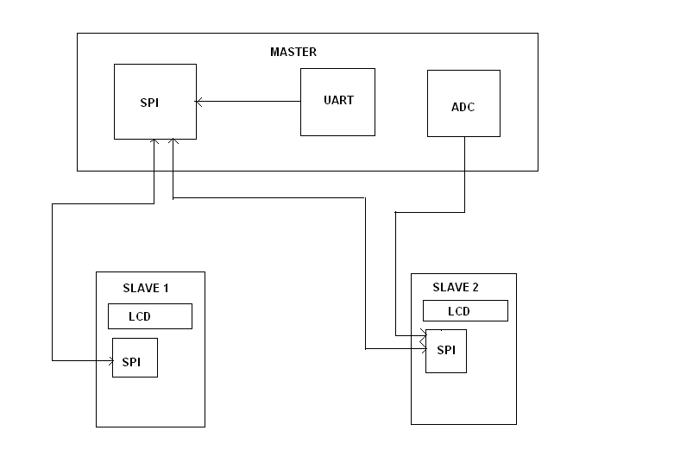

Group no :1

Meghashree (batch 149)

Ankita (batch 148)

Smrithy Santhosh(batch 147)

Steffy Joy(batch 147)